The Trustees of
Wingdale University
On recommendation of the faculty of the

College of Corn

Have conferred upon
Your Name Here

In recognition of fulfillment of the requirements, the degree of
Doctorate of Single Philosophy
With all the rights, privileges, and honors therein pertaining
Given at Wingdale, NY, this 28nd day of May, two thousand ten

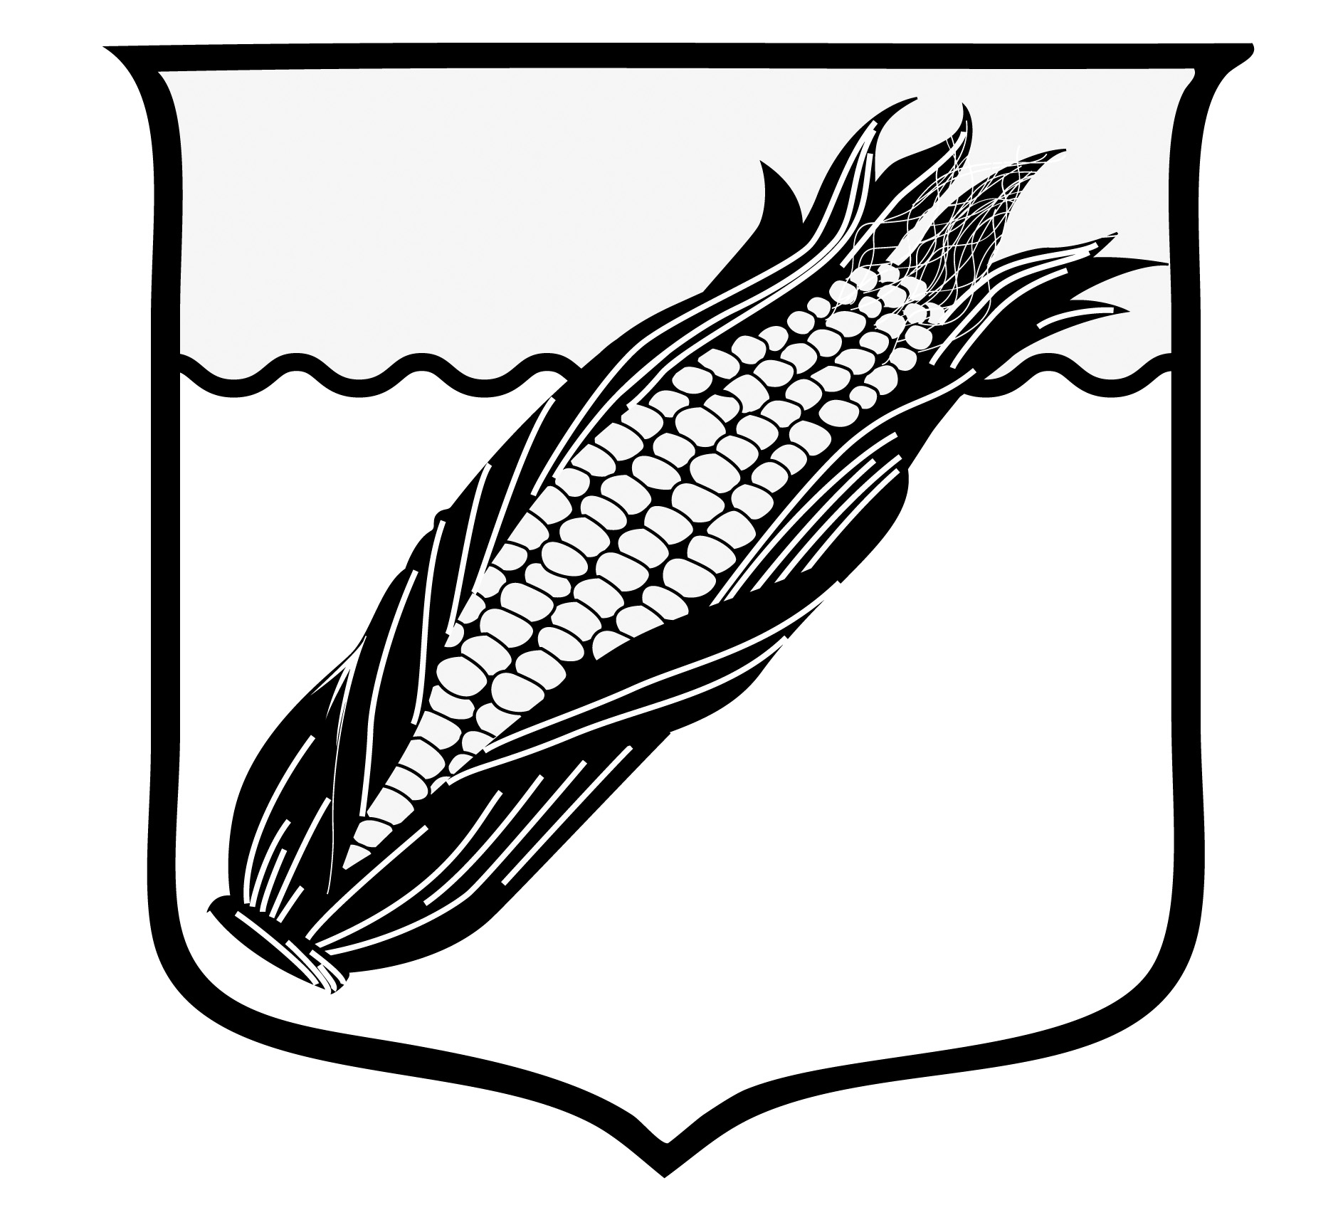

_____________________________________
University President

